Name: DUSHIME Sangwa Bertrand
ID: 27971
Course:PL/SQL database

PHASE II: Business Process Modeling

Business Process Explanation
Project: PL/SQL Medicine Batch Entry and Validation System (Med-Enter)
Process: New Medicine Batch Receipt and Validation
The Med-Enter system focuses on formalizing and securing the process by which a new supply of medicine (a new batch) is received and recorded into the inventory.
1. Define Scope: The scope is the end-to-end process from the pharmacist/inventory staff receiving a physical medicine shipment to the final, validated update of the digital inventory. This is highly relevant to MIS/Healthcare by ensuring data integrity and expiration safety.
2. Key Entities and Roles:
Pharmacist/Staff (User): Initiates the process by entering batch details.
PL/SQL Stored Procedure (System): The core automated processing engine (ADD_NEW_MEDICINE_BATCH).
Oracle Database (System): Stores all master and transactional data (MEDICINES, BATCH_INVENTORY, ALERTS LOG).
3. Organizational Impact & Justification: The key innovation is replacing manual, multi-step checks with a single, atomic, and transactional PL/SQL operation. This automation prevents human errors, immediately rejects unsafe entries (expired/near-expired batches) , and ensures instantaneous inventory reconciliation.
4. Analytics Opportunities (BI Potential):
Tracking batch rejection rate (number of rejected batches vs. successful insertions).
Monitoring the frequency and type of "LOW STOCK" alerts.
Analyzing expiry risk by tracking the total quantity of near-expired medicine logged in the ALERTS LOG.

Apply BPMN Notations:
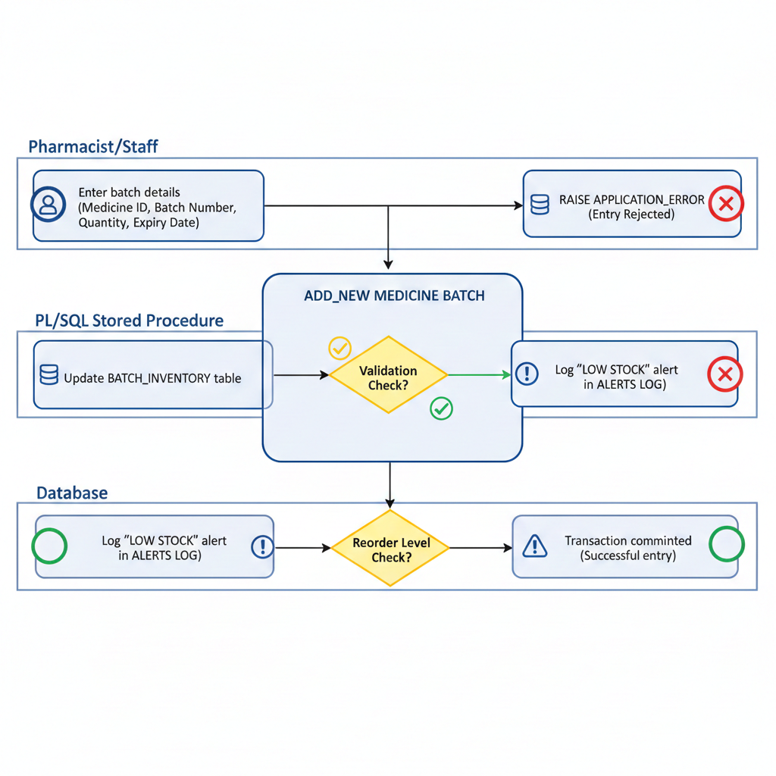

Flowchart of how the system works
